St. Patrick’s N.S. Pupil Voice

Article 12 of the United Nations Convention on Children's Rights states that "The child has the right to express an opinion, and to have that opinion taken into account, in any matter or procedure affecting the child, in accordance with his or her age and maturity."

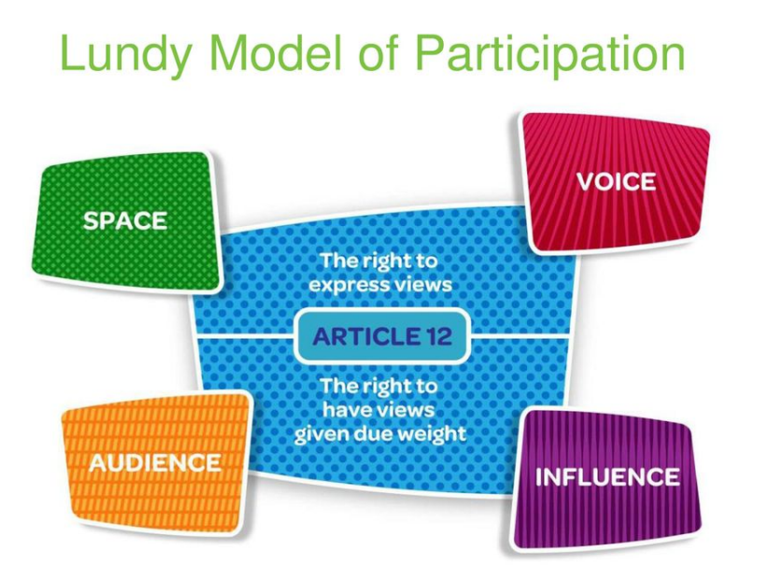
In our school we use the Lundy Model to facilitate the voice of pupils. In this model, children must be given space to express their views, they should be facilitated to do so, they should be listened to and have their opinions acted upon.
We have four areas in our school where pupils have a voice

Coiste Gaelbhratach - Tá páistí, tuismitheoirí agus múinteoirí ar an gcoiste seo ata ag deánamh iarracht chun an Ghaeilge a spreagach timpeall na scoile. This committee is comprised of pupils, parents and teachers who are promoting the use of Irish in our school.
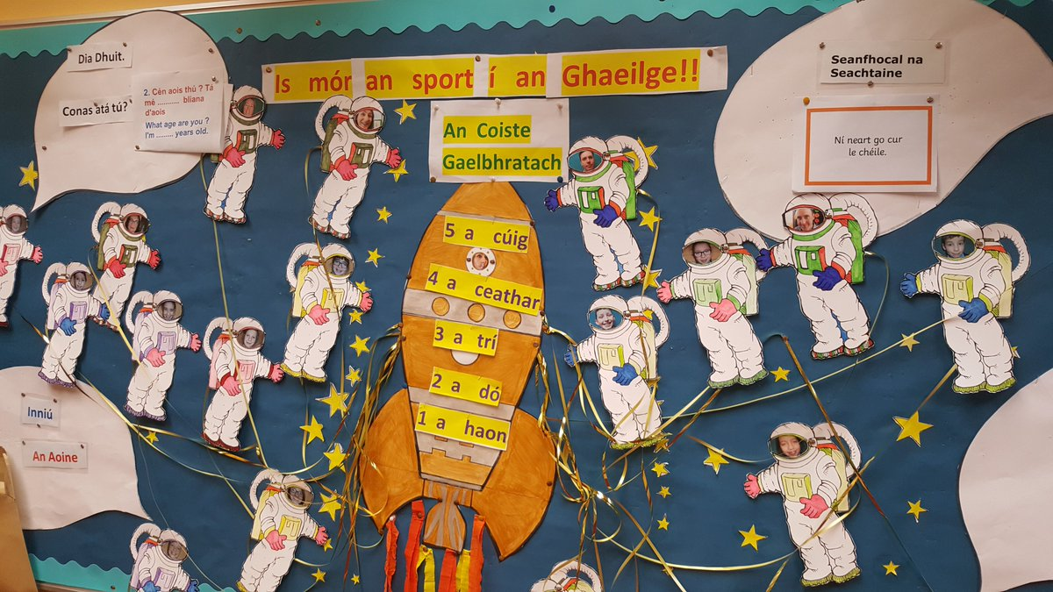

Green School Committee – Our school has a long history of caring for our environment. We have a number of green flags and a school garden. This committee, again comprising of pupils, teachers and parents, raise awareness among the school community of this area including inviting guest speakers and workshops, speaking to pupils at assembly and planning and completing practical tasks and initiatives in the school to raise awareness of the environment.
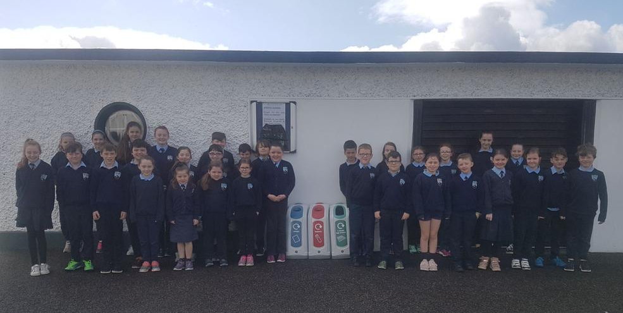

Active School Committee – Our Active School Committee is made up each year of sixth class pupils and the school principal. The committee plans activities to promote physical health in the school such as sports day, yard station teaching, 5K training and workshops and visits from guest speakers.
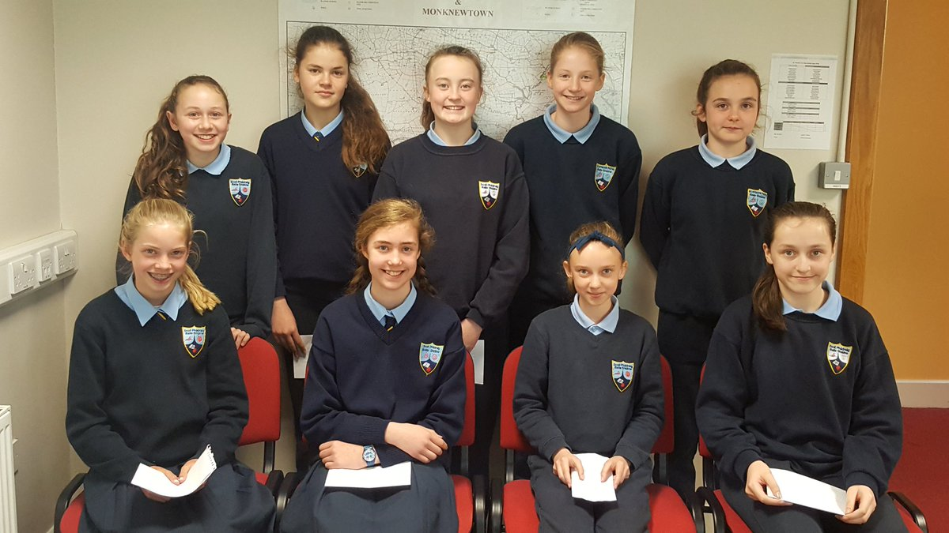

Gugalaí Gug Egg Company – Our fifth class pupils run a company which sells eggs from our school hens. The pupils created the company, organise all the tasks to look after the hens, collect the eggs and sell them to families in the school. They have paid back a loan for set up costs from our Parent Association and now reinvest the profits in resources they feel should be purchased for the school pupils.
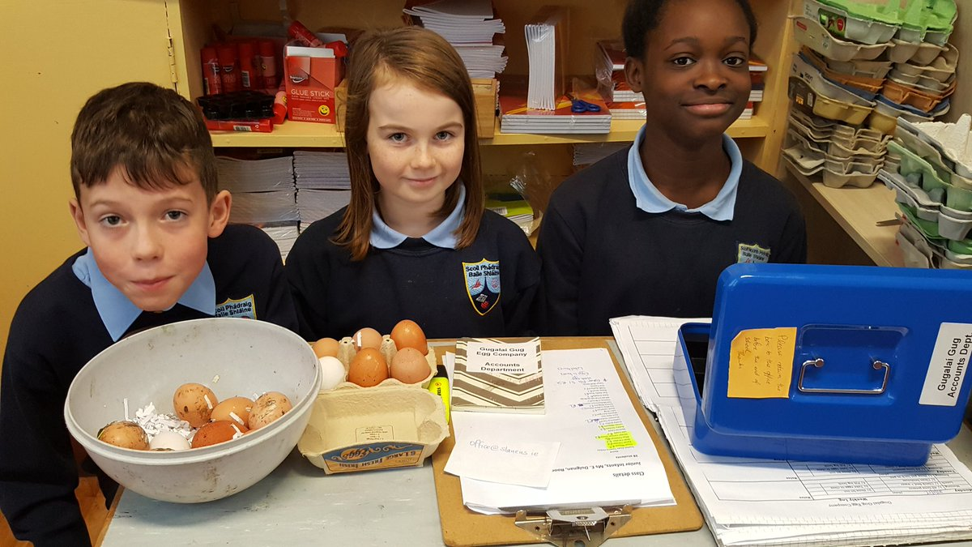

Other Areas - Pupils in senior classes also take part in surveys on areas relating to their school life each year. Most recently, pupils from third to sixth class gave feedback to teachers on teaching and learning methods used in a new piloted station teaching model implemented in these classes.

