School Self-Evaluation Pupil Focus Group (8) Senior Infants to 3rd Class including Children with Additional Needs December 2023

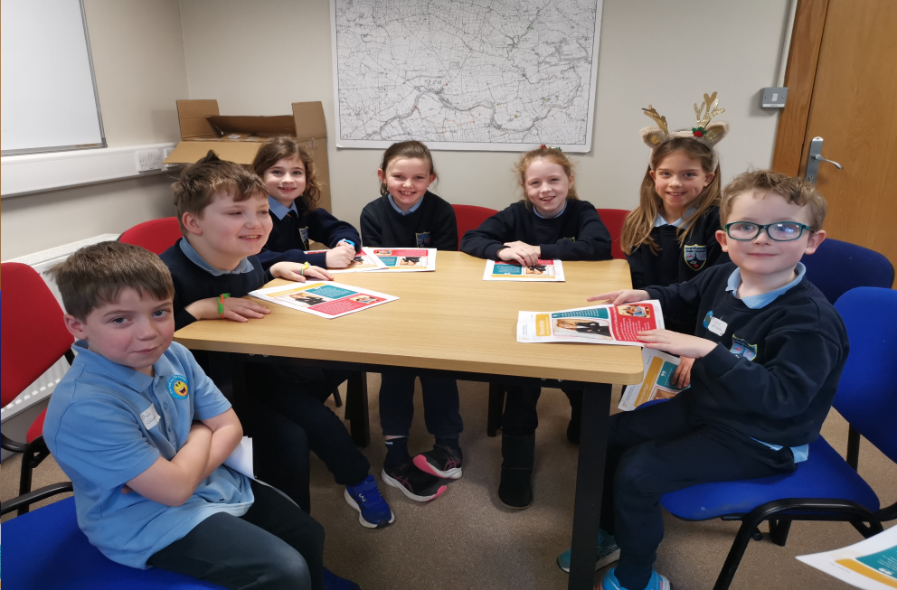

We had a wide ranging discussion about school life and how important it is that school leaders listen to children.

We also discussed the recent communication from the Department of Education Inspectorate to children about their work, inspections and school self-evaluation.

Finally, the pupils gave their opinions on music in St. Patrick’s National School.

- 100% enjoy music personally and in school
- 50% can play a musical instrument
- They enjoy singing, dancing to music, playing instruments, listening to music. One child said that it makes him feel relaxed and more confident.
- 80% play musical instruments in school but some of those appear to be at after school groups
- What the pupils would like more of is to learn to:
- Play a musical instrument in school
- Bring their own instruments to school to use in music lessons and
- Learn how to read music notes

