Sustainability Policy Statement

Introduction and Rationale
Sustainable development is development that meets the needs of the present without compromising the ability of future generations to meet their own needs (United Nations [UN], 1987). Sustainability is an urgent theme for us all to consider. The UN has recently stated that the coming years will be vital to save the planet Earth.
The 2030 Agenda for Sustainable Development (UN, 2015), is a plan of action for people, planet, prosperity and peace. This framework incorporates 17 Sustainable Development Goals to be achieved by 2030. The goals are underpinned by three pillars; Social, Economic and Environmental.

St. Patrick’s N.S. has a responsibility to enable future generations to manage resources wisely. Through our actions, we should develop positive habits and behaviour patterns in pupils and the wider school community to create a more sustainable planet for us all to live on.

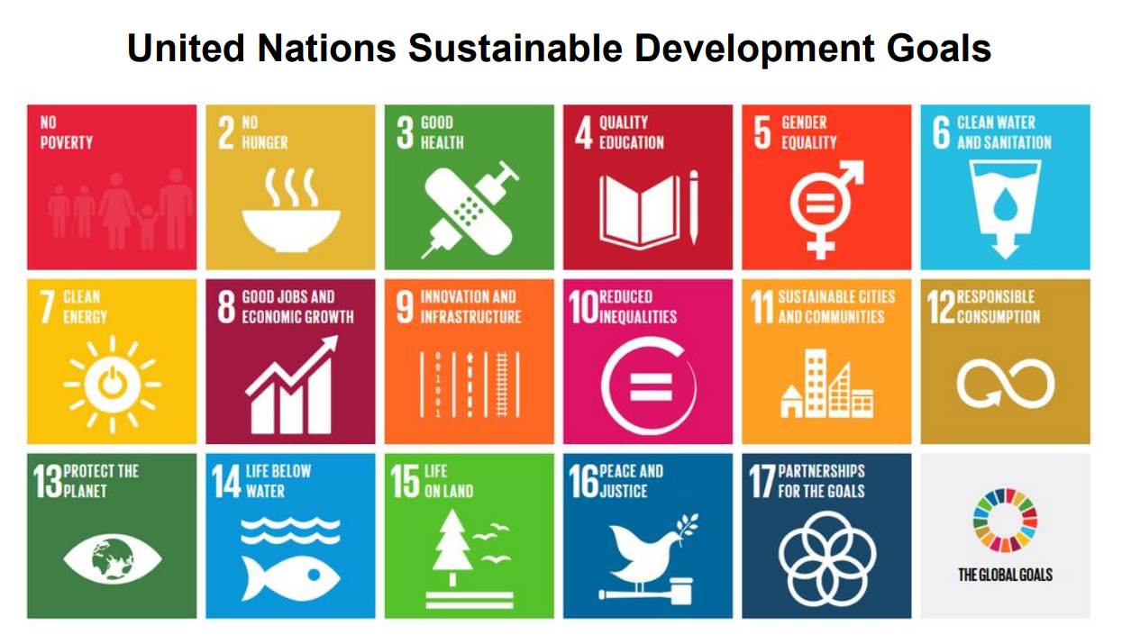

Vision
Education for Sustainable Development (ESD) empowers learners with the knowledge, skills, values and attitudes to take informed decisions and make responsible actions for environment integrity, economic viability and a just society empowering people of all genders, for present and future generations, while respecting cultural diversity (United Nations Education, Scientific and Culture Organisation [UNESCO], 2021). We seek to facilitate the pupils of St. Patrick’s N.S. to foster an appreciation and understanding of sustainability in general and ESD in particular, with a view to implementing it in their day to day lives.

Aims
- To enable each pupil to develop as a social being through living and cooperating with others and so contribute to the good of society
- To enable pupils in our school to become active citizens and agents for sustainability
- To implement a primary school curriculum, which promotes economic, social and environmental sustainability
- To identify relevant curricular areas to support learning about ESD, including the use of integration across subject areas and linkage within subjects
- To promote a range of pedagogical approaches that support sustainability through active learning, collaboration, communication, problem solving, critical thinking and creativity
- To focus on the child’s learning in the local outdoor environment, while also connecting to Ireland and the wider world
- To include and engage staff, pupils, parents, board members and the wider local community to implement practices that embed sustainability as a way of life
- To highlight the importance of social justice and equity, climate justice, anti-racism and interculturalism.
Underpinning Principles
- ESD to 2030 (Department of Education [DE], 2023) provides a framework to steer and support the contribution of education to promote a sustainable future
- Sustainability and ESD are for all pupils, staff, parents/ guardians and the wider school community
- Progression and continuity across class levels are an integral part of ESD planning
- ESD lends itself easily to integration between, and linkage within curricular areas
- A positive ethos and inclusive learning environment is encouraged, whereby all students feel welcome and belong. The school community promotes the active engagement of each pupil in sustainability and ESD.
ESD Integration Across and Linkage within Curricular Areas
The Primary School Curriculum (National Council for Curriculum and Assessment [NCCA], 1999) outlines a vision for primary education which enables pupils to meet with self-confidence and assurance, the demands of life, both now and in the future. While ESD can be integrated in all curricular subjects, Social Personal Health Education (SPHE) and Social Environmental and Scientific Education (SESE) are most strongly aligned with the Sustainable Development Goals.
The Primary Language Curriculum (NCCA, 2017) allows for opportunities for teaching, learning and assessing about sustainable development. ESD also allows for the integration of wellbeing for the individual pupil and the class group as a whole. This is an important consideration for our school’s Wellbeing Policy Statement and Framework for Practice.
In addition, one of the seven key competencies of the Primary Curriculum Framework (NCCA, 2023) is being an active citizen. This competency fosters the knowledge, skills, concepts, attitudes, values, and dispositions in children that motivate and empower them as citizens to take positive actions to live justly, sustainably, and with regard for the rights of others. It helps children to question, critique, and understand what is happening in the world within a framework of human rights, equity, social justice, and sustainable development. It also raises awareness of global challenges such as climate change, conflict, and growing inequalities.
You will also find United Nations Education Scientific and Cultural Organisation (UNESCO, 2023) lesson plans and resources for all class levels to support the teaching of the Sustainable Development Goals (SDGs) at the links below.
School Wide Approaches to Promoting The Sustainable Development Goals
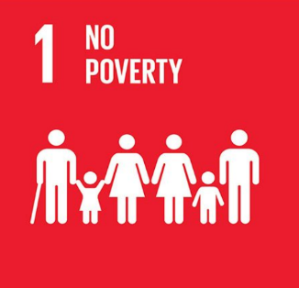
School is a space and place for sustainability and there are many opportunities for learning under the three pillars as outlined below:
- No Poverty
- School support for families in economic hardship
- Free book loan scheme for pupils
- Links with St. Vincent de Paul and fundraisers with other groups
- PA uniform recycling and Christmas jumper swap scheme
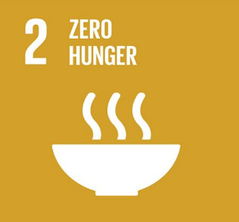
- Raise awareness of fair trade produce SDG 1 No Poverty - Teaching and Learning Resources
- Zero Hunger
- School support for families in economic hardship
- Christmas St. Vincent de Paul food appeal
- Reducing food waste by recycling waste in school composter
- Understanding of food cycle through school gardening SDG 2 Zero Hunger - Teaching and Learning Resources
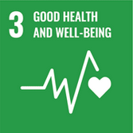
- Good Health and Wellbeing
- Extra-curricular activities to promote a healthy lifestyle
- Adequate time for eating lunch and drinks each day
- Implementation of emotional literacy programmes e.g. Friends for Life and Fun Friends
- School buddy system, friendship groups, Amber flag and wellbeing week
- Cross curricular teaching and learning to highlight benefits of connecting with others, sleep, diet, active lifestyle and harm associated with phone time, smoking, alcohol and drug use
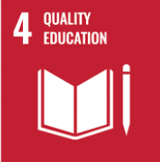
- School grounds are designed to facilitate recreational and educational use by pupils SDG 3 Good Health and Wellbeing - Teaching and Learning Resources
- Quality Education
- Good communication on transitions with pre and second level schools
- Caring relationships within the school community
- Use of pedagogical approaches that foster child engagement
- Partnerships between school, families and community
- Use of indoor and outdoor learning environments
- Inclusive education which celebrates diversity
- Engaging curricular experiences for children
- SDG 4 Quality Education - Teaching and Learning Resources
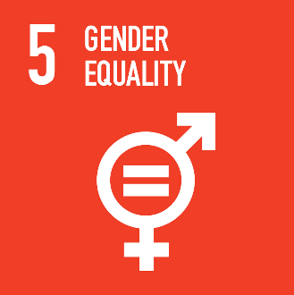
- Gender Equality
- That school policies ensure gender and sexual orientation are not barriers to participation
- Use of the curriculum to raise awareness of gender equality
- Clear expectations of staff relating to ensuring equality and anti-discrimination (inc. gender equality) in the workplace
- High standards and expectations for all pupils
- Equal opportunities to participate in curricular and extra-curricular activities for all pupils
- SDG 5 Gender Equality - Teaching and Learning Resources
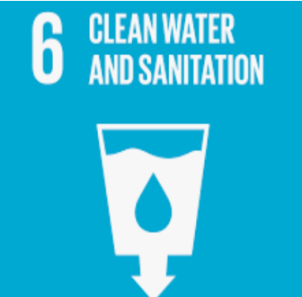
- Clean Water and Sanitation
- Use of school rainwater harvesting system, self-closing taps and cistern water saving devices to conserve water
- Cross curricular teaching and learning including the water cycle, local waterways, water as a resource and scarcity of water in parts of the world
- Promote water saving strategies for pupils at home
- Water as theme in St. Patrick’s N.S. Green School programme
- SDG 6 Clean Water and Sanitation - Teaching and Learning Resources
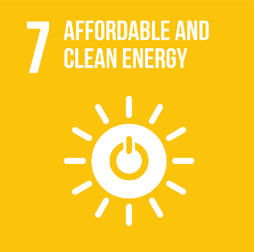
- Affordable and Clean Energy
- Use of motion sensors, insulation and thermostats in the school building to save energy
- Cross curricular teaching and learning including types of energy, energy sources and differences between renewable and non-renewable energy
- Energy as theme in St. Patrick’s N.S. Green School programme
- Promote energy saving strategies for pupils at home
- Staff to be role models in this regard by ensuring energy efficiency
- SDG 7 Affordable and Clean Energy - Teaching and Learning Resources

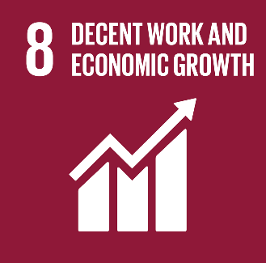
- Decent Work and Economic Growth
- Invitations to community to speak to pupils about their jobs
- Curricular teaching and learning relating to measures, money and financial planning SDG 8 Decent Work and Economic Growth - Teaching and Learning Resources
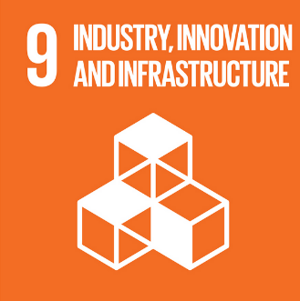
- Industry, Innovation and Infrastructure
- Fundraisers and initiatives in St. Patrick’s N.S. to promote health care in less well-off countries
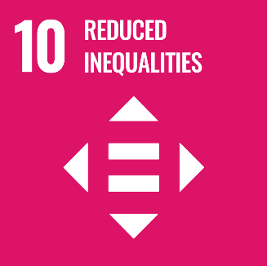
- Sustainable use of technology and electronics in our school SDG 9 Industry, Innovation and Infrastructure - Teaching and Learning Resources
- Reduced Inequalities
- That school policies ensure that diversity and inclusion are an important part of the learning environment in our school
- Cross curricular teaching and learning about inequalities, rights versus charity and solutions to these areas
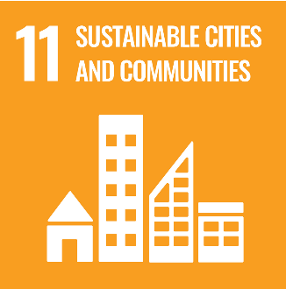
- Project work on other countries, Grandparents’ Day and cultural events to celebrate diversity and multiculturalism SDG 10 Reduced Inequalities - Teaching and Learning Resources
- Sustainable Cities and Communities
- Sustainable travel promotion via bicycle and scooter racks
- Cross curricular teaching and learning about the child’s local environment, sense of place, sustainability and travel
- Walk on Wednesdays and monthly awards to encourage more sustainable travel to school
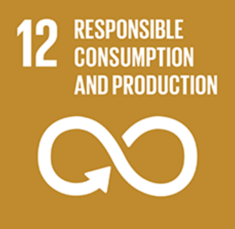
- Travel as theme in St. Patrick’s N.S. Green School programme SDG 11 Sustainable Cities and Communities - Teaching and Learning Resources
- Responsible Consumption and Production
- Responsible consumption and production through reducing paper use, recycling waste and recycling schemes for batteries, ink cartridges and paper
- Cross curricular teaching and learning to connect pupils to their local outdoor environment, understand sustainable practices to lower our carbon footprint, create good air quality, reduce waste and travel sustainably
- Litter and Waste as theme in St. Patrick’s N.S. Green School programme
- Promote sustainable consumption and production strategies for pupils at home
- SDG 12 Responsible Consumption and Production - Teaching and Learning Resources
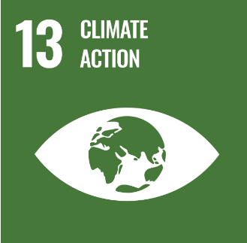
- Climate Action
- Promote responsible action to reduce our carbon footprint including sustainable travel, reusing items, recycling schemes for items and conserving energy and water
- Cross curricular teaching and learning to connect pupils to their local outdoor place, understand sustainable practices to lower our carbon footprint, reduce waste and promote environmentally friendly land use and modes of transport
- A specific focus on understanding climate change and action to motivate and empower them to promote a more sustainable future
- Biodiversity as theme in St. Patrick’s Green School programme
- SDG 13 Climate Action - Teaching and Learning Resources
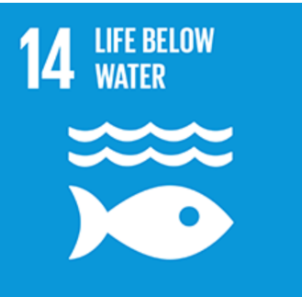
- Life Below Water
- Cross curricular teaching and learning to help pupils make meaningful connections with local waterways (school pond and River Boyne, national and global rivers and seas and plants and animals that depend on them to survive)
- Promote responsible recreational water activities through the school swimming programme SDG 14 Life Below Water - Teaching and Learning Resources
- Life on Land
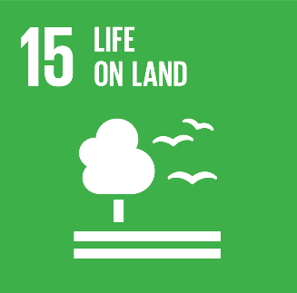
- Greening of school grounds to provide a biodiversity rich environments via hedges, trees, wildflowers, pond, raised beds for living thing habitats and pupil learning and play
- School sensory garden as outdoor pupil learning spaces
- Cross curricular teaching and learning highlighting importance of natural environment, range of local plants and animals, as well as threats to habitats and living things
- Promote biodiversity enhancing strategies for pupils at home
- Biodiversity as theme in St. Patrick’s N.S. Green School programme
- SDG 15 Life on Land - Teaching and Learning Resources

- Peace, Justice and Strong Institutions
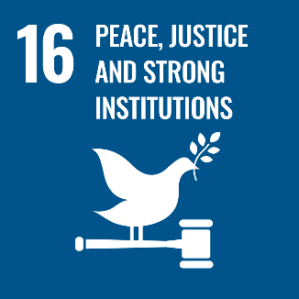
- Cross curricular teaching and learning relating to inclusion, multiculturalism, understanding religious and ethnic identities and need for mutual respect and understanding
- Enhancing pupil voice and understanding of democratic institutions through student council
- Global citizenship as theme in St. Patrick’s N.S. Green School programme
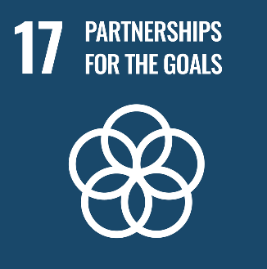
- SDG 16 Peace, Justice and Strong Institutions - Teaching and Learning Resources
- Partnership for the Goals
- Promotion of collaboration in school through group project work, initiatives and curricular activities
- Global citizenship as theme in St. Patrick’s N.S. Green School Programme
- SDG 17 Partnerships for the Goals - Teaching and Learning Resources

Assessment
Assessment in ESD ensures that the activities provided by the teacher meet the needs of the pupils, building on their growing expertise and understanding. It encompasses the many and varied situations in which the teacher observes the child's participation in education for sustainable development and in the application of knowledge, skills and understanding.

Assessment tools such as teacher observation, teacher designed tests and tasks, rubrics, interviews, self-assessment, peer assessment, classroom polling etc. can be used in both formative and summative formats to establish and develop learning.

Inclusion
ESD embodies themes such as inclusion, gender equality, skills for decent work and a global perspective as a means of empowering the individual and the community. In St. Patrick’s N.S., we promote a positive ethos and inclusive learning environment whereby all pupils, including those with additional needs, feel welcome and experience a sense of community and belonging.
We place an emphasis on promoting pupils’ participation and active engagement in their learning and in the life of the school and we are committed to developing pupils’ academic, social, emotional and independent living skills while placing a focus on high aspirations and on improving outcomes for all pupils.

Staff Development
All teachers have access to SPHE and SESE curriculum books, class programs and reference books. Information about in-service courses, school visits or upcoming events are communicated to staff via email, Aladdin and the staff notice boards. Teachers are encouraged to attend relevant in-service courses, webinars and podcasts throughout the year and during the summer. They are also encouraged to share relevant information during staff meetings or via email. Opportunities for teacher observations and team-teaching are encouraged in our school. This can be managed by way of arrangement between the individual teachers concerned.
Parental Involvement and Community Links
Parents can support their children in fostering an interest in sustainability by:
- Involving their children in and encouraging them to live sustainable lifestyles
- Modeling a respect for human rights, gender equality and cultural diversity
- Promoting a culture of peace and non-violence
- Encouraging them to be proud, responsible and meaningful global citizens
- Attending or assisting at school-related sustainability events.
Members of the community with particular interest or expertise in sustainability may also be invited to share their knowledge with the pupils. All such visits must be discussed with the principal and the class teacher must be always present.
Success Criteria
The success criteria of this plan will be measured by the following criteria:
- Implementation will be evident through teaching and learning in the school
- Ongoing evaluation should demonstrate that pupils are acquiring an understanding of the SDGs and an increasing awareness of sustainability.

Roles and Responsibility
The policy will be supported, developed and implemented by all teachers. The relevant postholder will co-ordinate the progress of the plan and will encourage and accept feedback on its implementation. They will also report back to the staff on findings.
Review
It will be necessary to review this plan to ensure optimum ESD implementation in the school.

Signed: Fr. Richard Matthews
Board of Management Chairperson

Bibliography
Brundtland, G. (1987) Report of the World Commission on Environment and Development: Our Common Future. Geneva: United Nations. Available at: http://www.un-documents.net/our-common-future.pdf [Accessed 11 March 2023].

Department of Education [DE] (2022) ESD to 2030:Second National Strategy on Education for Sustainable Development. Athlone: DE. Available at: https://www.gov.ie/pdf/?file=https://assets.gov.ie/228330/c69895a6-88f0-4132-b6d1-9085a9c31996.pdf#page=null [Accessed 11 March 2023].

National Council for Curriculum and Assessment [NCCA] (1999) Primary School Curriculum: Introduction. Dublin: The Stationery Office

National Council for Curriculum and Assessment [NCCA] (2017) Primary Language Curriculum Curaclam Teanga na Bunscoile. Dublin: The Stationery Office

National Council for Curriculum and Assessment [NCCA] (2018) Education for Sustainable Development: A Study of Opportunities and Linkages in the Early Childhood, Primary and Post-primary Curriculum. Dublin: NCCA. Available at: https://ncca.ie/media/4899/education-for-sustainable-development.pdf [Accessed 11 March 2023].

National Council for Curriculum and Assessment [NCCA] (2023) Primary Curriculum Framework. Dublin: NCCA. Available at: https://www.curriculumonline.ie/getmedia/84747851-0581-431b-b4d7-dc6ee850883e/2023-Primary-Framework-ENG-screen.pdf [Accessed 11 March 2023].

United Nations [UN] (2015) Transforming Our World: The 2030 Agenda for Sustainable Development. New York: United Nations. Available at: https://sdgs.un.org/2030agenda [Accessed 11 March 2023].

United Nations Education, Scientific and Cultural Organisation [UNESCO] (2021) Berlin Declaration on Education for Sustainable Development. Berlin: UNESCO. Available at: https://en.unesco.org/sites/default/files/esdfor2030-berlin-declaration-en.pdf [Accessed 11 March 2023].

United Nations Education, Scientific and Cultural Organisation [UNESCO] (2023) “Sustainable Development Goals – Resources for Educators”. Accessed 11 March 2023. https://en.unesco.org/themes/education/sdgs/material

